Slov. Antropol., Volume(Issue):Pagination, Year of Publication (in the competence of the editors)
Black line, font size 12, simple line spacing, without spaces before and after paragraphs
TITLE OF THE MANUSCRIPT (CAPITAL LETTERS, BOLD, FONT SIZE 14, LEFT MARGIN ALIGNMENT)
Black line, font size 12
Author’s name and surname¹, Author’s name and surname ² (bold, font size 12)
Black line, font size 12
¹ Affiliation of the 1st author (University, Faculty, Department, full address, e-mail)
² Affiliation of the 2nd author (University, Faculty, Department, full address)
Black line, font size 12
Abstract: Maximum length of 200 words, font size 12, simple line spacing. Abstract must include the objective of the study, information about the examined individuals/skeletal remains and achieved results. Txt, txt, txt, txt, txt, txt, txt, txt, txt, txt, txt, txt, txt, txt, txt, txt, txt, txt, txt, txt, txt, txt, txt, txt, txt, txt, txt, txt, txt, txt, txt, txt, txt, txt, txt, txt, txt, txt, txt, txt, txt, txt, txt, txt, txt, txt, txt, txt, txt, txt, txt, txt, txt, txt, txt, txt, txt
Black line, font size 12
Key words: 6 – 10 words, separated by comma, font size 12, they should not repeat expressions from the title
Black line, font size 12
Introduction
Font size 12, simple line spacing, 1st line indent 0.5 cm, block alignment.
Txt, txt, txt, txt, txt, txt, txt, txt, txt, txt, txt, txt, txt, txt, txt, txt, txt, txt, txt, txt, txt, txt, txt, txt, txt, txt, txt, txt, txt, txt, txt, txt, txt, txt, txt, txt, txt, txt, txt, txt, txt, txt, txt, txt, txt, txt, txt, txt, txt, txt, txt, txt, txt, txt, txt, txt, txt.
Black line, font size 12
Material and methods
Font size 12, simple line spacing, 1st line indent 0.5 cm, block alignment.
Txt, txt, txt, txt, txt, txt, txt, txt, txt, txt, txt, txt, txt, txt, txt, txt, txt, txt, txt, txt, txt, txt, txt, txt, txt, txt, txt, txt, txt, txt, txt, txt, txt, txt, txt, txt, txt, txt, txt, txt, txt, txt, txt, txt, txt, txt, txt, txt, txt, txt, txt, txt, txt, txt, txt, txt, txt (table 1).
Black line, font size 12
Results and discussion (can be separate)
Font size 12, simple line spacing, 1st line indent 0.5 cm, block alignment.
Txt, txt, txt, txt, txt, txt, txt, txt, txt, txt, txt, txt, txt, txt, txt, txt, txt, txt, txt, txt, txt, txt, txt, txt, txt, txt, txt, txt, txt, txt, txt, txt, txt, txt, txt, txt, txt, txt, txt, txt, txt, txt, txt, txt, txt, txt, txt, txt, txt, txt, txt, txt, txt, txt, txt, txt, txt (figure 1).
Black line, font size 12
Conclussions
Font size 12, simple line spacing, 1st line indent 0.5 cm, block alignment.
Txt, txt, txt, txt, txt, txt, txt, txt, txt, txt, txt, txt, txt, txt, txt, txt, txt, txt, txt, txt, txt, txt, txt, txt, txt, txt, txt, txt, txt, txt, txt, txt, txt, txt, txt, txt, txt, txt, txt, txt, txt, txt, txt, txt, txt, txt, txt, txt, txt, txt, txt, txt, txt, txt, txt, txt, txt.
Black line, font size 12
Acknowledgement
Txt, txt, txt, txt, txt, txt, txt, txt, txt, txt, txt.
Black line, font size 12
References
See Guidelines for Authors for more information. (hypertext)

Table 1: Captions of the table (font size 12)
Notes (font size 12)

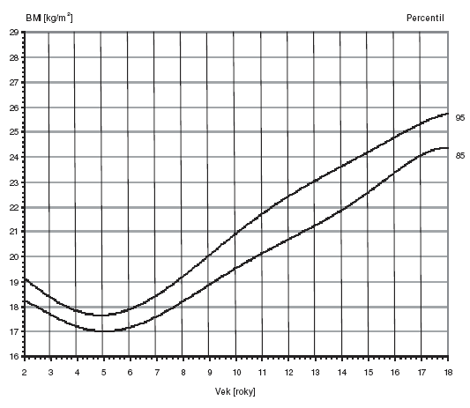
Fig. 1: Captions of the picture (font size 12)

